

v4.0.0

User Manual

Getting Started
mangoO Microfinance Management is a software solution for small scale (usually single-branch) micro-finance institutions. It was first developed for Luweero Diocese SACCO (Savings and Credit Cooperative) in Luweero, Uganda.
As mangoO is based on web technology, you will need a web browser to use the program. It is recommended to use Mozilla Firefox, Chrome, or Chromium. Your administrator should have provided you with an address or link to gain access to mangoO.
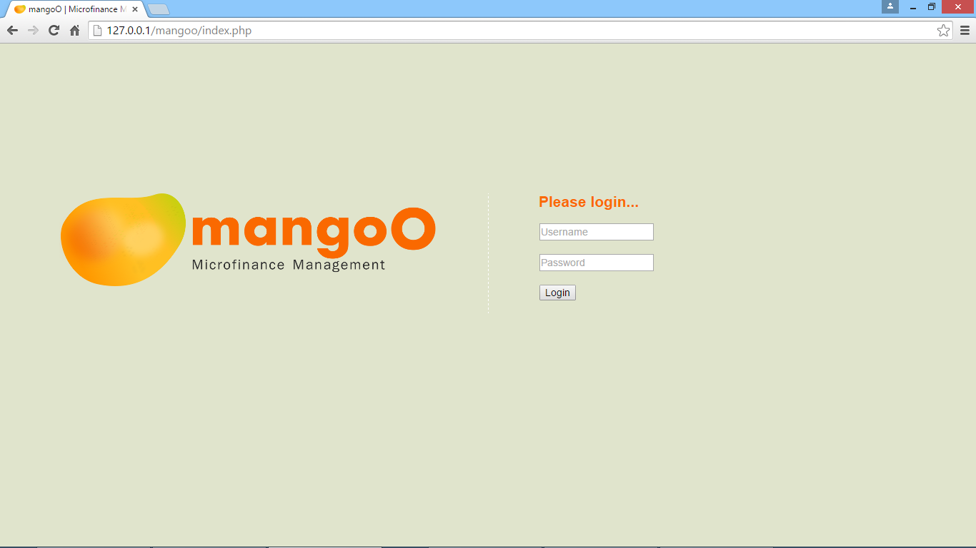
On the start page of mangoO, please provide a valid user name and password. In case you do not possess such login information, please contact your system administrator.

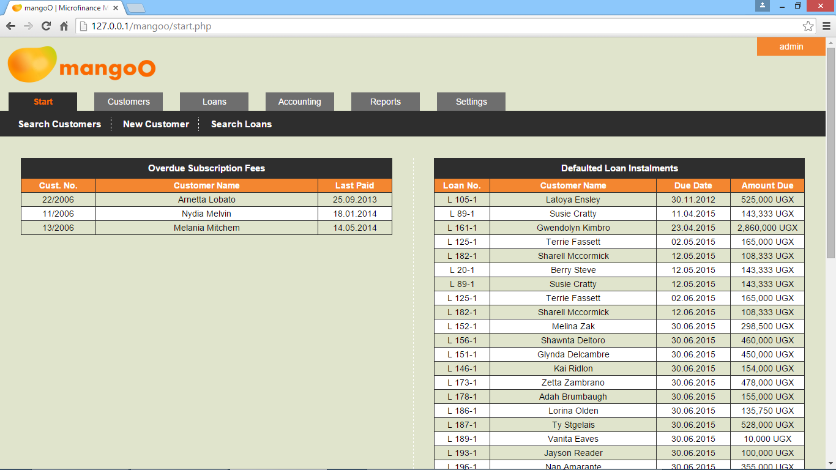
Dashboard
After logging in, the system will take you to the dashboard. Depending on the system's basic settings (see 8.1.1), you will find different types of information.
The Overdue Subscription Fees list will display all customers whose annual subscription has expired. In order to access a customer's record, click the respective customer number. Depending on the respective setting (see Fehler: Referenz nicht gefunden), customers might automatically be set to inactive, if their subscription has expired.
The Defaulted Loan Instalments table shows all currently defaulted loan instalments. In order to access the loan's record, click the respective loan number. Depending on the respective setting (see 8.2.5), defaulters might automatically be charged a predefined default fine which will be deducted from their savings accounts.
The different statistics widgets present a momentary snapshot of the institution's business situation.
The options in the upper menu bar give you quick access to the most frequently used functions. Search Customers accesses the customer search form (see 2.1), Search Loan the loan search form (see 4.1), and New Customer allows you to create a new customer record (see 2.2).

Customers
Under Customers you will find all tools for managing customer records.

Customer Search
The customer search form allows you to search the database for customers depending on a variety of search criteria.
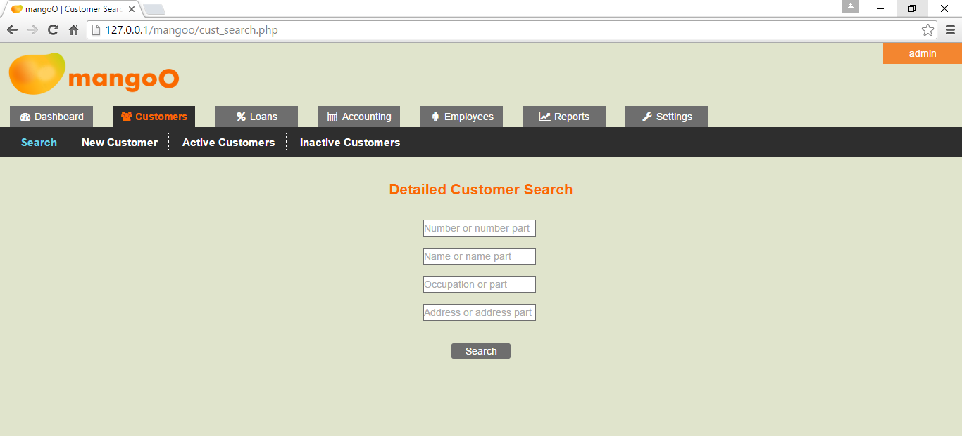
The input fields allow for searches by customer details such as the customer's number or part of it, name or name part, occupation or part of it, address or address part. As such details are, by nature, ambiguous, the search will take you to a result page. The result list can be exported by clicking Export.
mangoO will search for any customer on the database whose details match all specified search criteria. For example, a search for occupation teacher and address Luweero will yield a list of all customers who work as teachers and reside within Luweero. Customers who are teachers but reside in other places will not be included in the result.
The search is case-insensitive and works regardless of the search term's position within the respective data field. For example, a search for the name string shu will yield Shumate as well as Joshua. If a given search criteria does not match with any details in the database, the search result list will remain empty.
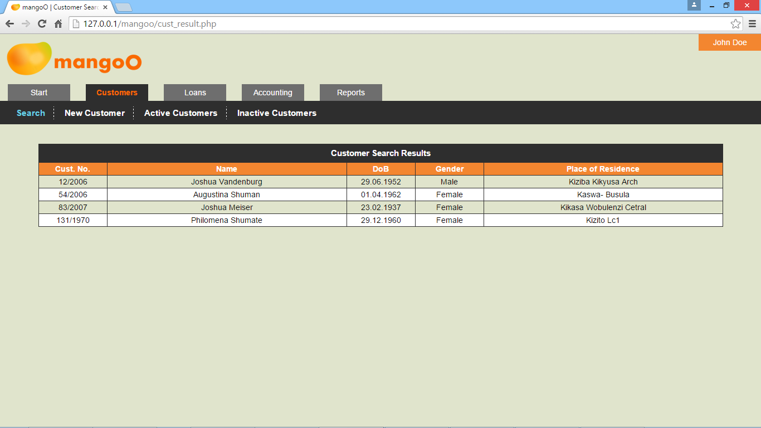
In order to access a customer's record from the search result page, click the respective customer's number.

New Customer Record
This page allows you to enter a new customer record into the database.
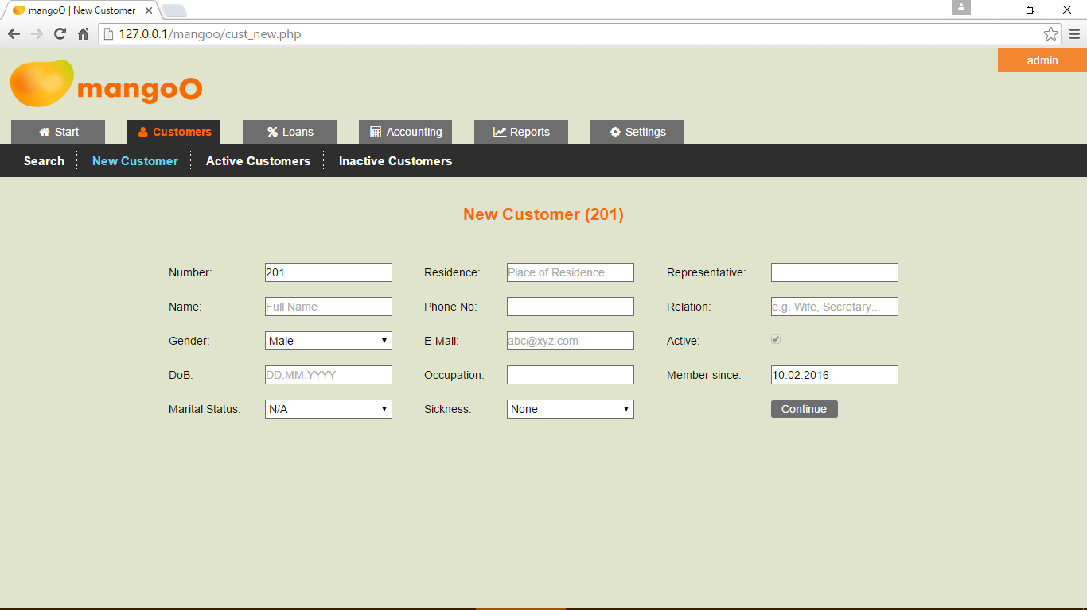
Customer numbers are automatically generated and assigned by the system and cannot be altered by the user.
The fields for name, date of birth, place of residence, and phone number are compulsory to fill. In addition, mangoO will perform consistency checks on entered phone numbers and email addresses.
The system will automatically assume the current date to be the date when the new customer registered with the institution. In case the customer joined at an earlier date, you may adjust the value of Member since accordingly. Please note that throughout mangoO, all dates must be given in the format DD.MM.YYYY (for example 03.01.2016).
New customers are by definition considered to be active. Thus, the activity status cannot be changed on registration. Finally, a receipt number for the entrance fee must be specified.
On clicking Continue, the new record will be written to the database. In a next step, mangoO will allow you to upload a picture of the respective customer. Permissive file formats are JPG, JPEG, PNG, TIF, and TIFF. In case you do not wish to upload a picture, choose Skip.

Predefined Lists of Customers
In addition to the search function, mangoO offers two predefined lists of customers by status.

List of Active Customers
The short link Active Customers will show a list of all customers whose status is currently set to Active. You may access a particular record by clicking the respective customer number.
Clicking Export above the list will generate an XLS file which can then be altered, printed, sent, or otherwise used outside mangoO.

List of Inactive Customers
The short link Inactive Customers will show a list of all customers whose status is currently inactive. You may access a particular record by clicking the respective customer number.
Clicking Export above the list will generate an XLS file which can then be altered, printed, sent, or otherwise used outside mangoO.

Customer Details Page
When retrieving a customer's record, either through searching or through selection from one of the lists, mangoO displays all information on the respective customer on a comprehensive details page.

Basic Customer Data
The data fields on the left-hand side show the customer's basic data. They can be changed any time by overwriting the respective field and clicking Save Changes.
Every data update will be logged by the system and displayed in Updated on / by. Due to the nature of the information, the data in Member since, Subscription paid until, and Updated on / by cannot be changed manually.

Customer's Photo
In case a photo has been uploaded for the respective customer (see 2.2), his/her picture will show on the left side of the details page. Clicking it allows to upload a new photograph for the respective user. If no photo has been uploaded so far, a place-holder picture will be shown. Click it to upload a new photograph for the respective customer.

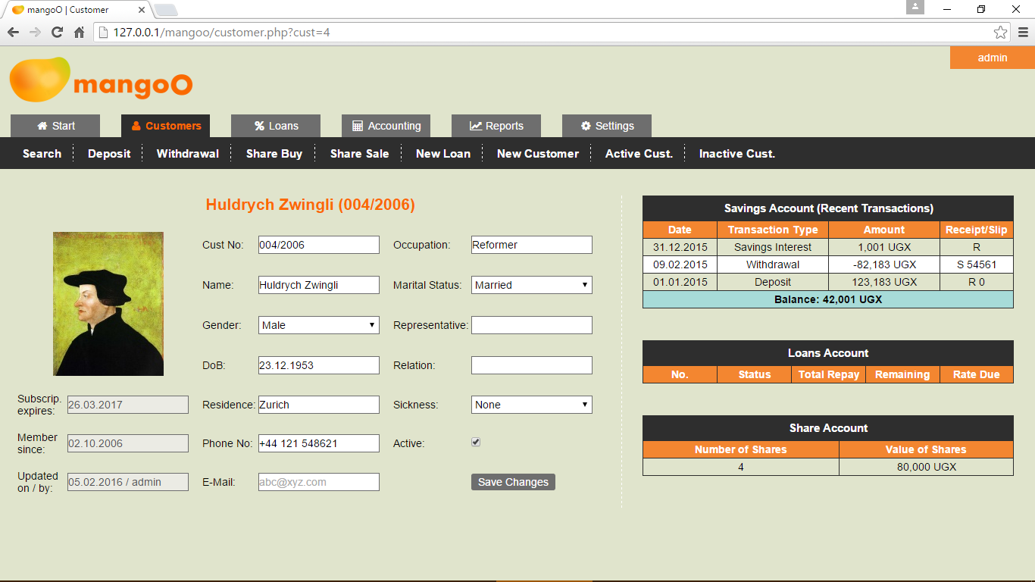
Membership Renewal
In case the annual subscription check is enabled (see 8.1) and the customer's subscription has expired, a warning message will appear and mangoO will automatically show a renewal form below the customer's basic data.
By default, the system assumes the current date to be the date of membership renewal. Should the customer have renewed his membership earlier, please adjust the date accordingly. You must then specify a receipt number and choose whether or not the subscription fee should be deducted from the customer's savings account. Clicking Renew Membership will renew the customer's subscription for one year and automatically set his status to active.

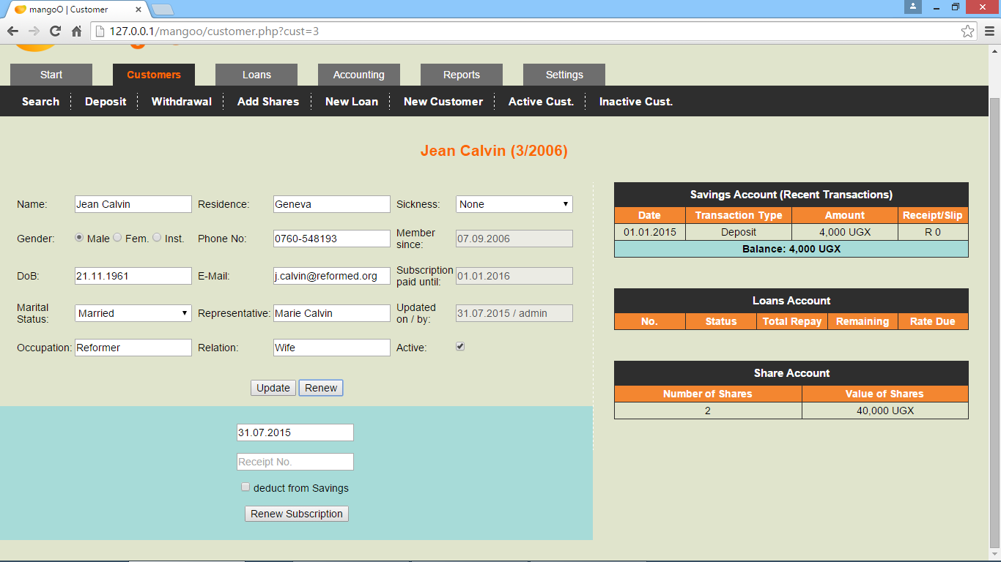
Accounts' Details
The right-hand section provides you with a summary of the customer's accounts. For the sake of space, the savings account table will show the five most recent transactions only. You may access a complete list of all transactions on the savings account by clicking Savings Account in the table header. The shared column for Receipt / Slip numbers indicates the nature of a given number by a preceding R for receipts and a preceding S for withdrawal slips. (See 3.2 for further details on the savings account.)
The loans account table shows all past and recent loans. You can access the details of a particular loan by clicking on the loan number. (See 4 for further details on the loans account.)
Lastly, the share account table gives a summary on the currently owned number of shares and the combined value of these shares. Clicking on Share Account in the table header will take you to the share account with a complete list of all transactions. (See 3.1 for further details.)

Additional Options in the Menu Bar
When viewing customer details, the menu bar above provides you with a number of different options regarding that respective customer.
The options Deposit and Withdrawal will both take you to the customer's savings account where you may perform either operation (see 3.2).
The Share Buy and Share Sale options will take you to the customer's share account where you may add, transfer, or sell shares (see 3.1 for more information on shares).
The New Loan option allows you to create a new loan application for the customer (see 4.4).

Account Types
By default, mangoO keeps three different accounts for each customer: Share Account, Savings Account, and Loans Account.

Share Account
You may access a customer's share account either by clicking Share Account in the table header on the customer's details page, or through the Share Buy or Share Sale option in the menu bar above the customer's basic information.

Retrieving account information
The share account page is divided into two sections. The right-hand side will provide you with a comprehensive list of all transactions on the customer's share account. Clicking the Delete-icon allows authorised users (see 8.5) to delete the respective transaction after entering a security captcha.
Clicking Export will generate an XLS file containing the complete history of transactions on this account.
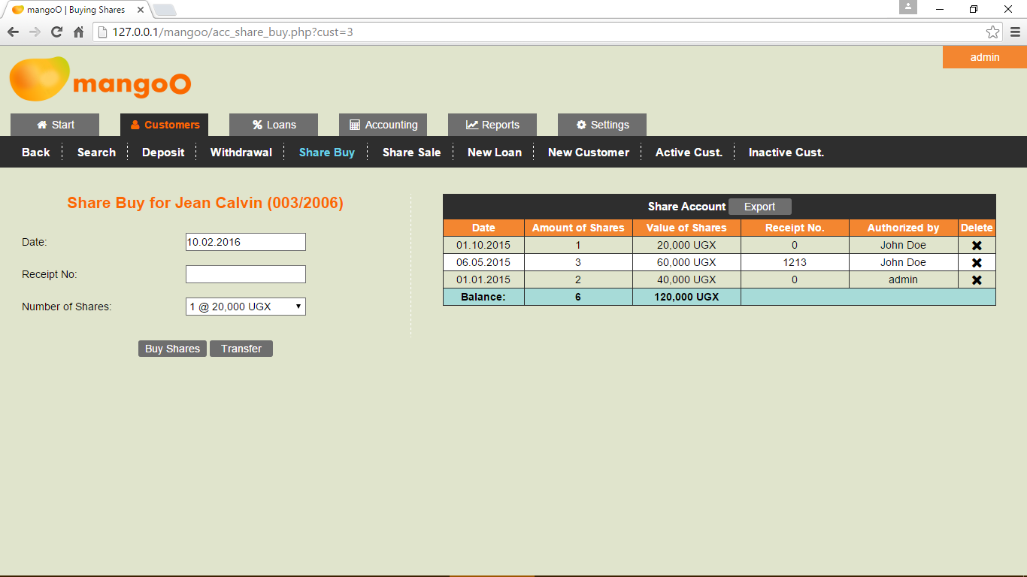

Share Buys
Under Share Buy, the left-hand side allows you to add more shares to a customer's account.
The system will assume the current date to be the date of share acquisition. In case the customer bought his additional shares at an earlier date, please adjust the date accordingly. Specifying a receipt number for the transaction is compulsory. The drop-down field Number of Shares allows you to choose the number of shares bought by the customer. The system will automatically calculate the amount due, based on the current price for one share. (The share value can be edited by authorised users only. See 8 for more details.)

Transfer of shares
In case a customer wishes to terminate his membership with your financial institution, you may use Transfer to transfer shares from another customer to the currently displayed account. In order to do that, please choose from the drop-down field the customer who is ending his membership and click Transfer Shares. The currently displayed customer will then be credited with all the shares previously owned by the leaving customer. The share account of the leaving customer will be set to zero and his membership will be deactivated.

Share Sales
Under Share Sale, the customer can sell shares back to the issuing financial institution.
The system will assume the current date to be the date of share sale. In case the customer sold his shares at an earlier date, please adjust the date accordingly. Specifying a receipt number for the transaction is compulsory. The drop-down field Number of Shares allows you to choose the number of shares sold by the customer. The system will automatically calculate the value, based on the current price for one share. (The share value can be edited by authorised users only. See 8 for more details.)

Savings Account
You may access a customer's savings account by either clicking Savings Account in the table header on the customer's details page, or through either the Deposit or the Withdrawal option in the menu bar above the customer's basic information.

Retrieving account information
The savings account page is divided into two sections. The right-hand side will provide you with a comprehensive list of all transactions on the customer's savings account. Clicking the Delete-icon allows authorised users (see 8.5) to delete the respective transaction after entering a security captcha.
Clicking Export will generate an XLS file containing the complete history of transactions on this savings account.

Deposits
Depending on the option you chose, the form on the left-hand side allows you to conduct deposits on the customer's savings account. The system will assume the current date to be the date of the transaction. In case the customer deposited at an earlier date, please adjust the date accordingly. Specifying the amount and a receipt number for the transaction is compulsory.
In case a person other than the account holder deposited money, you may enter the name of the depositor.
If the Fixed-term Savings option is enabled (see 8.1.3), you may furthermore enter the date until which the respective deposit is fixed. In order to pay interest on a deposit, change the transaction type to Savings Interest. In this case, the amount will be included as an expense in the expense report.

Withdrawals
Depending on the option you chose, the form on the left-hand side allows you to conduct withdrawals from the customer's savings account. The system will assume the current date to be the date of the transaction. In case the customer withdrew at an earlier date, please adjust the date accordingly. Specifying the amount, a withdrawal slip number, as well as a receipt number for the transaction is compulsory.
The bottom-most check-box allows you to have the withdrawal fee deducted from the savings account. In this case, the charged fee will appear as a separate transaction on the account, showing the same date, receipt, and slip number as the original withdrawal itself.
mangoO will automatically insert the specified withdrawal fee into the incomes record in the accounting section. (The amount of the fee, however, can be changed by authorised users only. See 8.3.3 for more information.)
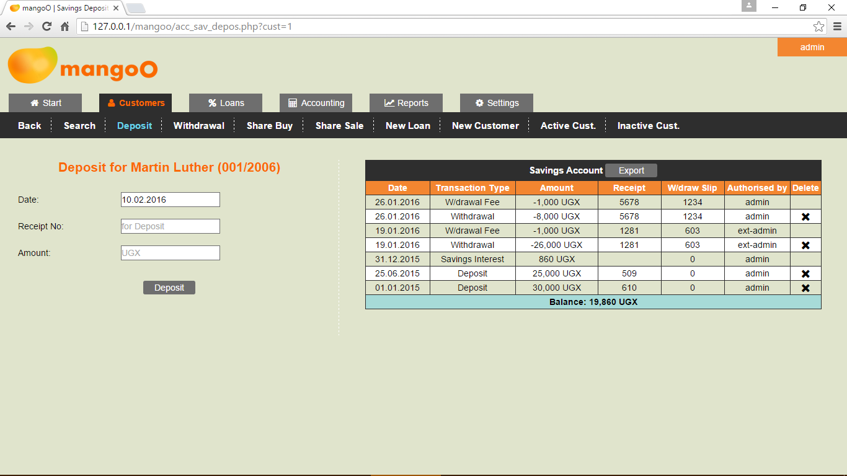

Loans Account
As the Loans Account is the most complex of all account types, the topic of loans is covered in a separate chapter. Refer to chapter 4 for more information.

Loans
There are two ways of accessing a particular loan. One is to retrieve the details of the respective borrower. In the section displaying a customer's accounts, the loans table will show all past and recent loans. You can access the details of a particular loan by clicking on the loan number. (See also 2.4.3.)
Alternatively, you may search for a particular loan number straight away. Selecting the Loans tabs will take you to a search form for loans.

Loan Search
The upper input field is used to search for loans by number. Enter the loan number (or part of it) into the input field and click Search. The search result list will show all loans whose numbers match with the specified search term. You may access a particular record by clicking on the respective loan number. If a given number does not exist in the database, the search result list will be empty.
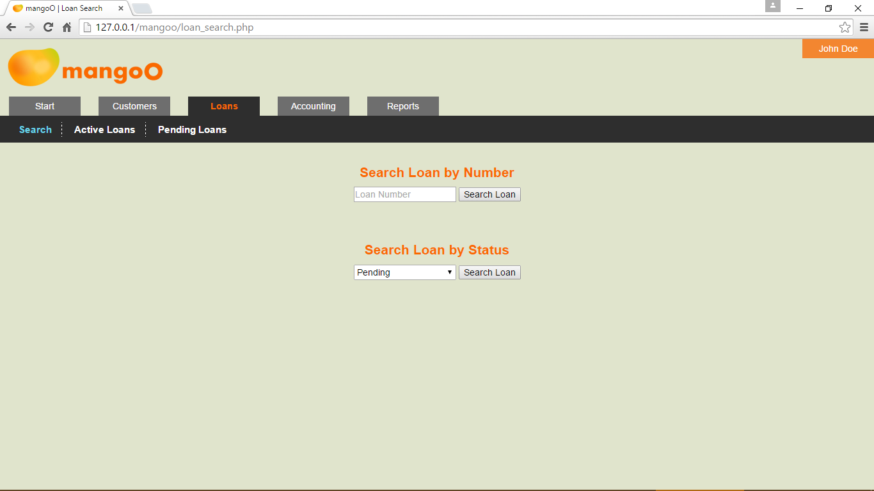
The lower input field allows for searches by status. Select a particular status from the list and click Search. The mangoO system will provide you with a search result list including all loans that have the respective status. You may access a particular record by clicking on the respective loan number.

Predefined Lists for Loans
In addition, mangoO offers two predefined lists of loans by status.

List of Active Loans
The short link Active Loans will show a list of all loans whose status is currently set to active. You may access a particular record by clicking on the respective loan number.
Clicking Export will generate an XLS file which can then be altered, printed, sent, or otherwise used outside mangoO.

List of Pending Loans
The short link Pending Loans will show a list of all loans whose status is currently set to pending. You may access a particular record by clicking on the respective loan number.
Clicking Export will generate an XLS file which can then be altered, printed, sent, or otherwise used outside mangoO.

Loan Details Page
After accessing a particular loan, either through searching or through the account of the borrowing customer, mangoO will provide you with a comprehensive overview of all details concerning the respective loan.

Basic Loan Data
The left-hand section of the page presents all basic data about the loan. Apart from the status, none of this information can be changed manually.

Security Documents
In case a document or photograph was attached to one or both securities while entering the loan (see 4.4), the respective securities are follow by an eye symbol. Attached files can be accessed by clicking on the respective security.
If no document has been attached, securities are followed by an upload symbol. To later attach a relevant document, click on the respective security (see 4.4.1).
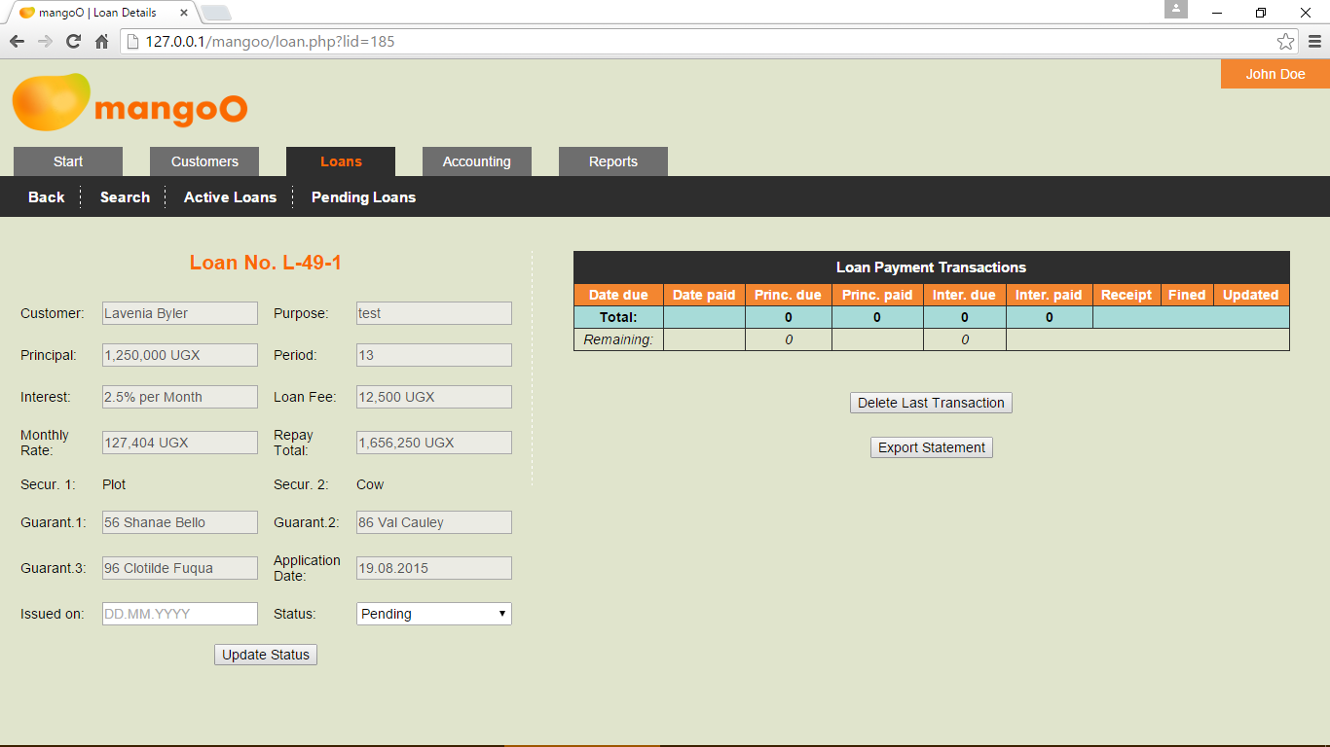
After entering a new loan (see 4.4) into the system, mangoO will automatically have set the status of that loan to Pending. Such a loan is registered because it was applied for by one of the institution's customers. However, a pending loan has not yet been approved, let alone issued.

Rejecting a Pending Loan
On pending loans, the only option is to update the status of that loan. In case a loan application has been rejected, the loan status must be set to Refused and Update Status must be clicked. Please note that even rejected loans will remain on the system for later reference.

Approving a Pending Loan
In case a loan application has been approved, the loan status must be set to Approved. The date of issuing must be specified in the DD.MM.YYYY format.
The system assumes that the approved principal will be equal to the applied principal amount. In order to disburse an amount different from the original applied principal, adjust the amount in the Principal approved field.
On clicking Update Status, the system will prompt you to specify the receipt number for the loan fee (and any additional fee you might have specified. See 8.3.4).
When a loan is approved, mangoO will generate a list of expected loan repayment transactions on the right-hand side of the page (see 4.3.2). Please note that due dates are calculated based on the date of issuing and that 31 days are allowed between payment dates.

Loan Payment Transactions Data
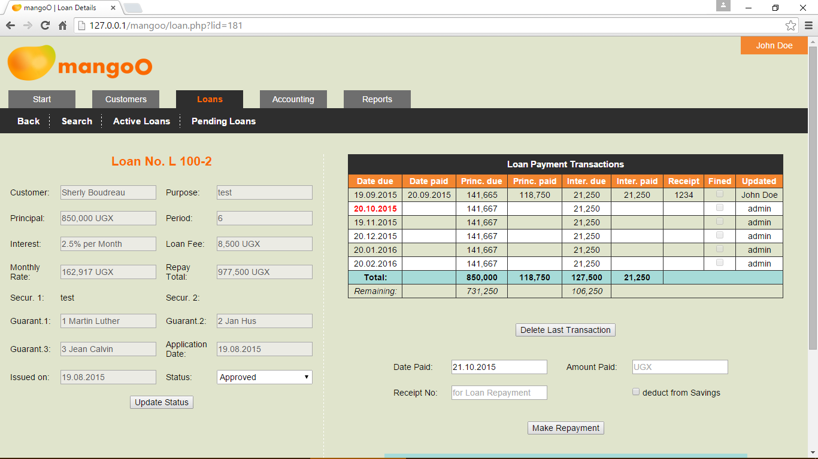
The right-hand section of the page presents data about loan payment transactions. While a loan is still pending, this section will be empty. On approval, the system will automatically have generated a list of expected loan repayment transactions (see 4.3.1.3). Please note that due dates are calculated based on the date of issuing and that 31 days are allowed between payment dates.

Making a Repayment
In case of a repayment, please enter the date (by default the current date is assumed), the receipt number, and the total amount paid by the customer. Please also indicate whether the amount should be deducted from the customer's savings account.
The system will automatically divide the amount paid based on the idea, that the due interest for the month is always served first. This results in the following rules:
- In case the customers brings less than the due interest, the entire amount will be used to cover interest only.
- In case the customer brings more than the due interest but less than the total expected monthly rate (interest plus principal), interest will be cleared first and the remaining amount will be used on principal.
- In case the customers brings more than the total expected monthly rate, any excess money will be used to clear principal.
- In case a customer brings more than the total outstanding balance on both interest and principal, both positions will be cleared and excess money will be deposited on the customer's savings account.
Any payment of interest will reflect on the incomes side in the accounting section (see 6.2).

Error Correction
The mangoO system allows the user to revert loan payment transactions. Clicking the delete-icon allows authorised users (see 8.5) to delete the respective transaction after entering a security captcha. This is a safety feature to assure the wilful execution of the delete command.

Defaulted Payments and Default Fines
In the Loan Payment Transactions list, due dates which lie in the past and have not been met, are indicated in red. In this case, the system will show a blue box below the payment section which allows you to charge a default fine. To do so, please enter the date (by default the current date is assumed), the receipt number, and the total amount charged as fine. You must also indicate whether the amount should be deducted from the customer's savings account. Kindly note that this is the default setting!
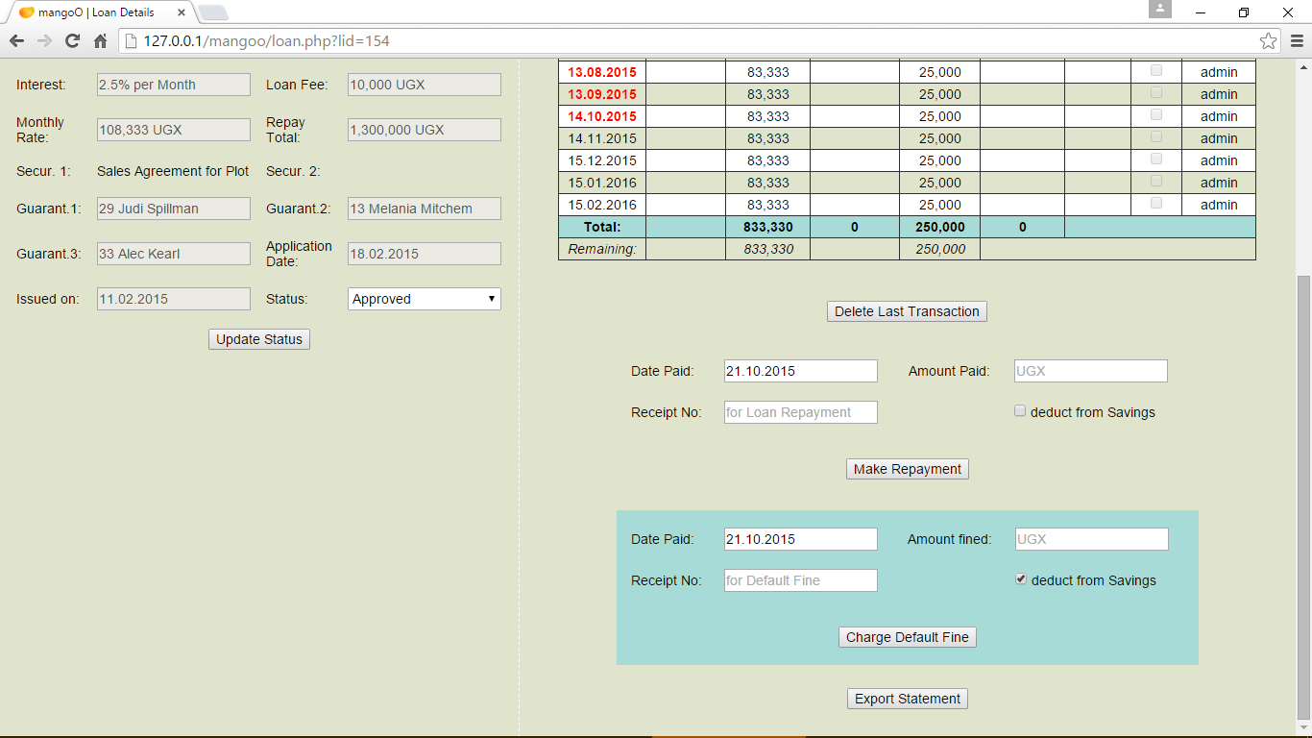
Any payment of a default fine will reflect on the incomes side in the accounting section (see 6.2). Please be aware that mangoO will always assume a default fine to apply to all outstanding transactions. Therefore, all currently defaulted payments will be marked as Fined.

Export Loan Statement
Clicking Export will generate an XLS file containing the complete history of transactions on this particular loan.

Entering a New Loan
In order to enter a new loan application, you first have to open the dataset of the customer (see 2.1) who wishes to apply for the loan. Provided the customer's membership status is Active, you will find an option in the upper menu bar called New Loan . Clicking it will allow you to fill a new loan application for that customer.
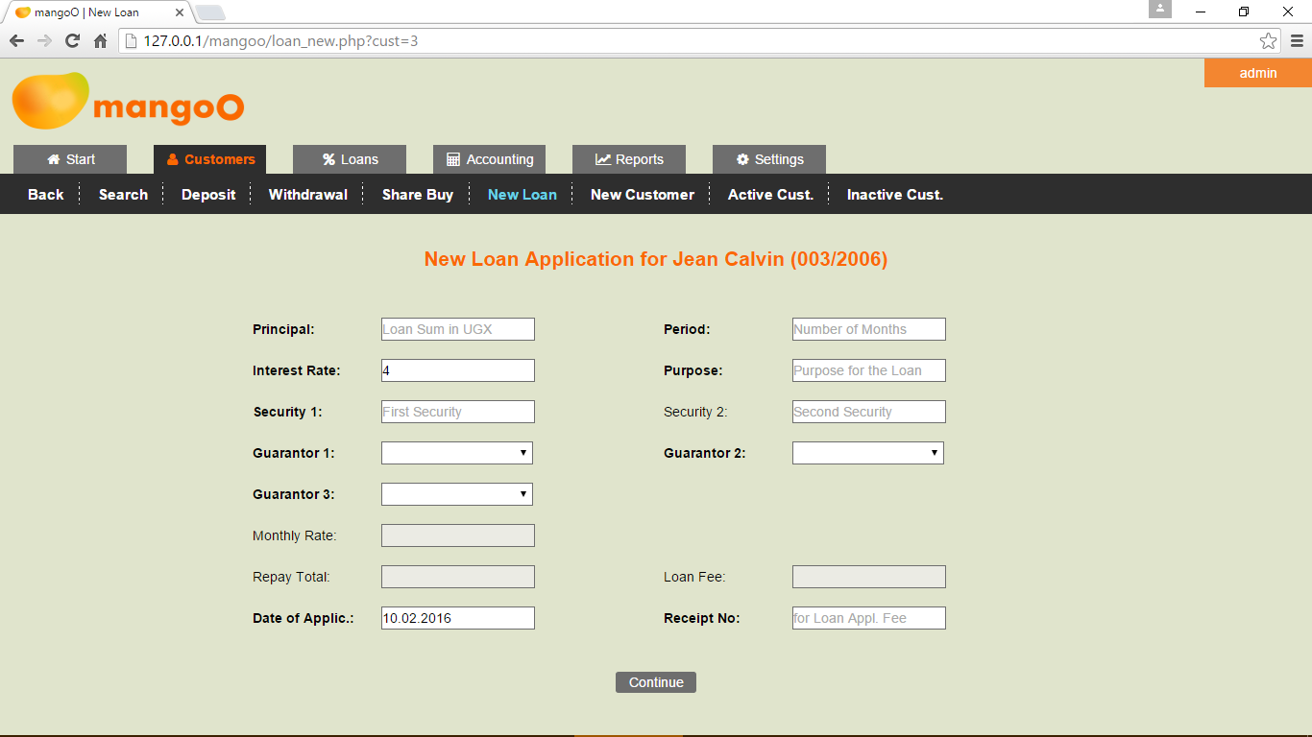
In order to enter a new loan application in the system, fill all compulsory fields. As soon as the information on principal, loan period, and interest rate is entered, mangoO will calculate the monthly repayment rate, the total repay amount, and the applicable loan fee.
By definition, guarantors can only be active members of the institution and must be selected from the lists.
On completion, please click Continue.

Uploading Security Documents
The next page allows you to upload documents that further describe the specified securities. Depending on the number of securities, mangoO will offer you one or two option for uploading. You may want to attach photos, scans, or other documents related to the securities. Those documents will later be accessible through the loan's details page (see 4.3.1).
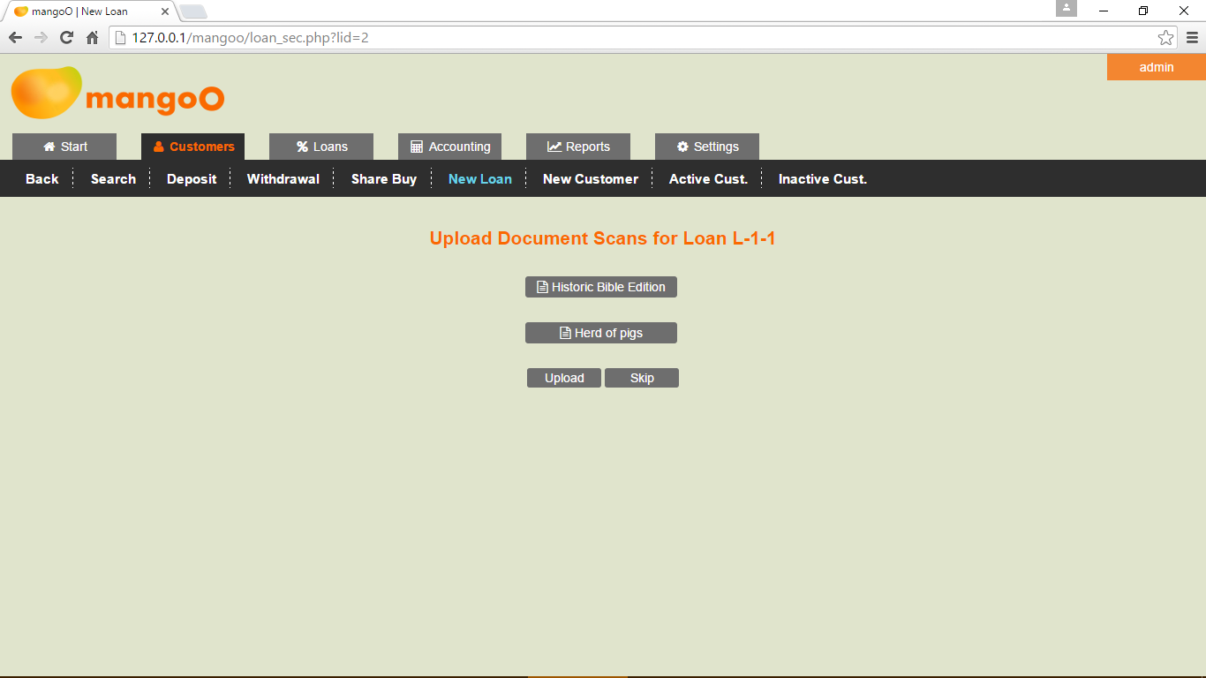
In order to attach any document to a security, click Choose File, navigate to the location of the file on your computer, and select it for upload. The system will only allow you to choose PDF, JPG, JPEG, PNG, TIF, TIFF, DOC, DOCX, XLS, XLSX, ODT, ODS and TXT files.
Clicking Upload will upload all selected files to mangoO.
Should you not wish to attach documents to any of the securities, click Skip.

Employees
This part of mangoO allows to manage all employees of the microfinance institution. Clicking Employees takes you to a list of all currently employed workers.
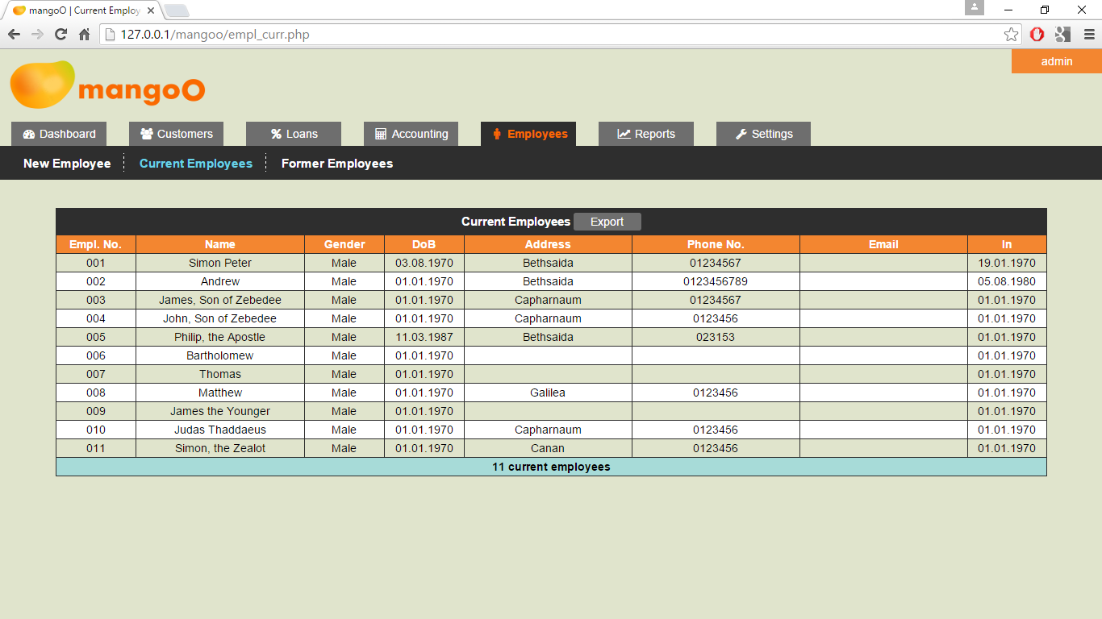
The table lists all workers who have either no end date set or the specified end date still lies in the future.
On clicking Former Employees, the system will generate a list of all employees, whose end of employment date lies in the past.

Employee Details Page
On both lists, you may select any employee by clicking the employee number. This will take you the respective employee's details page. Here you may alter the employee's personal details, such as number, names, contact details, salary, and others.

Employee Picture
In order to upload a new picture of an employee, click the existing picture or the place-holder.

Linking Employee and mangoO System User
The button User will take you to the user settings page (see 8.4.4). If the respective employee was already linked to a mangoO system user, that user will be loaded into the edit fields. Otherwise, you may create a new user and link the employee to this new user record.
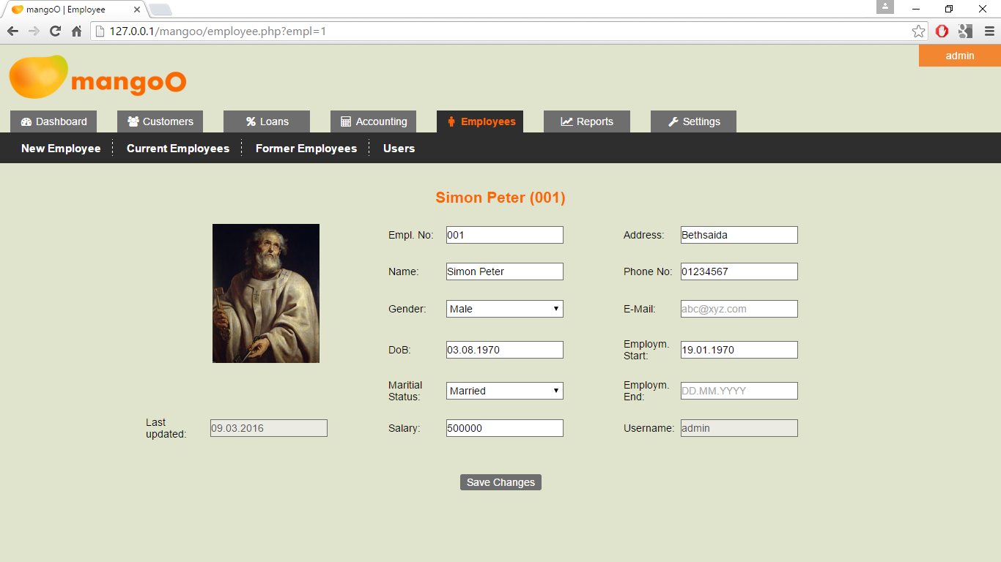

New Employee Record
In order to create a new employee record, simply click New Employee. The following form will allow to enter all details of the new worker.
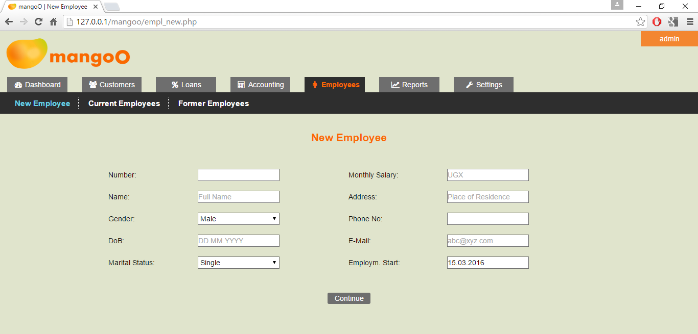
On clicking Continue, the new record will be written to the database. In a next step, mangoO will allow you to upload a picture of the respective employee. Permissive file formats are JPG, JPEG, PNG, TIF, and TIFF. In case you do not wish to upload a picture, choose Skip.

Accounting
mangoO Microfinance Management can also be used for internal accounting purposes. Under Accounting you will find three options Expenses, Incomes and Annual Accounts.

Expenses
Use this option to record all expenses of your micro-finance institution.
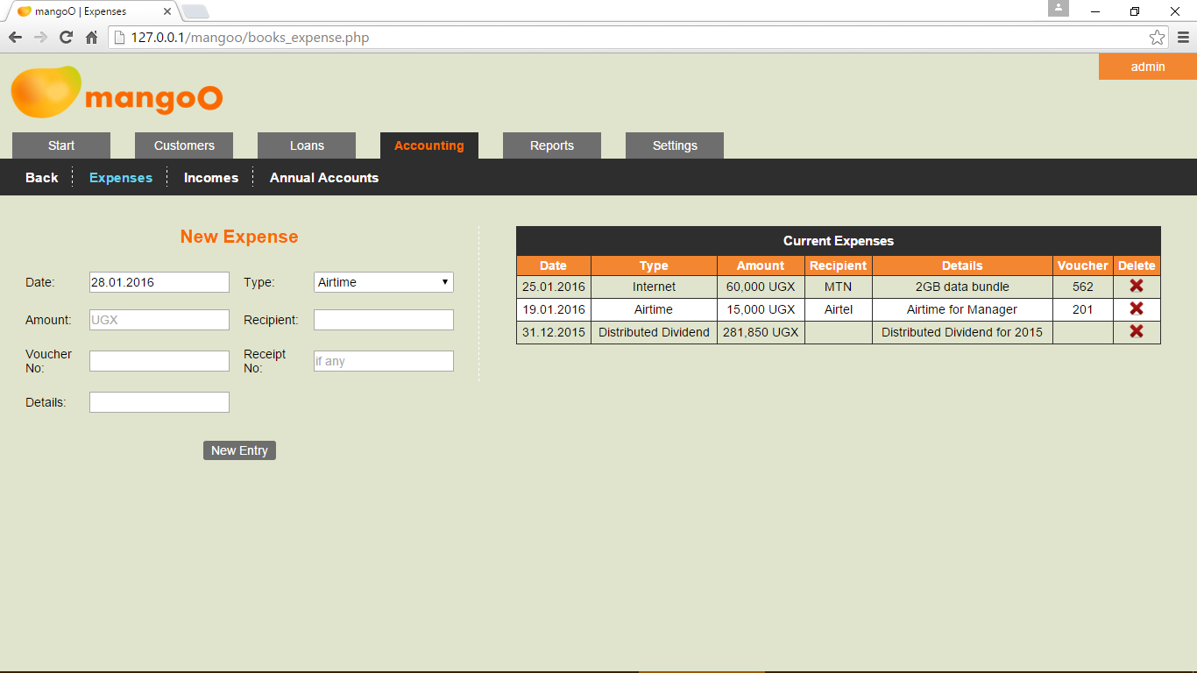
In order to record a new expense, enter all necessary information. Amount, recipient and payment voucher number are compulsory to include. Make sure to also choose an appropriate expenditure type from the list. (Expenditure types can be edited or amended by system administrators only.)
In order to enter the information into the system, click New Entry.
On the right-hand side, mangoO shows a list of all expenditures for past 60 days. Any further representation of accounting data is limited to the Reports section (see 7).
Clicking the delete-icon allows authorised users (see 8.5) to delete the respective transaction after entering a security captcha.

Incomes
WARNING: Under normal circumstances, this option is rarely ever needed! The mangoO system is designed to record all incomes automatically whenever they are generated from the institution's business. This means that payable fees, payments of interest, and other forms of income are captured automatically as they happen. However, instances might occur in which the manual recording of an income is inevitable. In this case, use this option to record such an income. Make sure this remains an exceptional incident!
In order to manually record a new income, enter all necessary information. Amount and receipt number are compulsory to include. Make sure to also choose an appropriate income type from the list. (Please note that income types can be edited or amended by system administrators only.)
In order to enter the information into the system, click New Entry.
On the right-hand side, mangoO shows a list of all incomes of the past 60 days. Further representation of accounting data is limited to the Reports section (see 7).
Clicking the delete-icon allows authorised users (see 8.5) to delete the respective transaction after entering a security captcha. Not all income types can be deleted from this list. Some, like Withdrawal fees, must be deleted by deleting the transaction that triggered this income.

Annual Accounts
This option is used to close a financial year and payout an annual share dividend and an annual savings interest to customers.
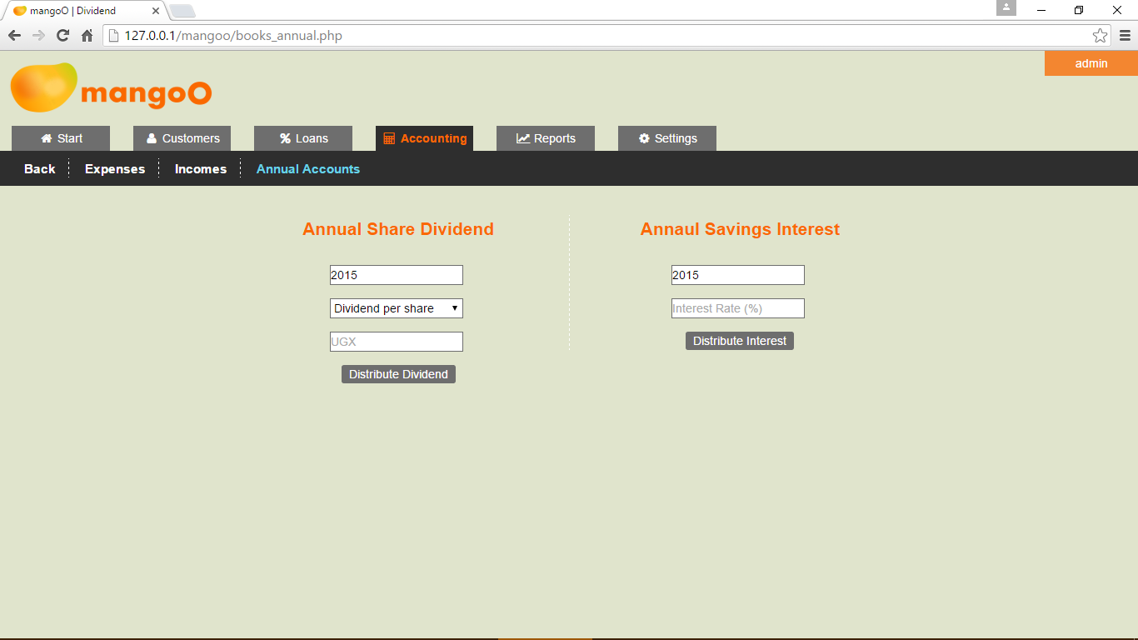

Annual Share Dividend
You may either enter a dividend per share or the grant total amount of your annual dividend.
In either case, mangoO calculates the proportion of dividend to which a customer is entitled based on the length of time the customer was holding his / her shares during the given year.
If the dividend was given on a per share basis, mangoO will credit every customer's savings account with a proportionate amount.
If the specified dividend was grand total, mangoO will first divide this amount by the number of eligible shares to calculate the dividend per share. Then, all eligible savings accounts will be credited with a proportionate amount. Please note that due to rounding differences the distributed total might not entirely add up to exactly match the initially entered grand total amount.

Annual Savings Interest
To distribute the annual savings interest to your customers, enter the respective year and interest rate as percentage.
mangoO calculates the amount of interest to which a customer is entitled based on his / her average savings balance for the given year.
Please note that only active customers are granted interest.

Reports
Reporting is used to evaluate the institution's business activities. As this would typically be the work of management staff only, access to these reports is restricted to certain user accounts.
mangoO offers four different types of individual reports (Income Report, Expense Report, Loans Report, and Capital Report) plus two summarizing report types (Monthly and Annual Report). In order to generate a report, choose a type, select a time period and the desired format in the light-blue menu bar, and click Select Report.
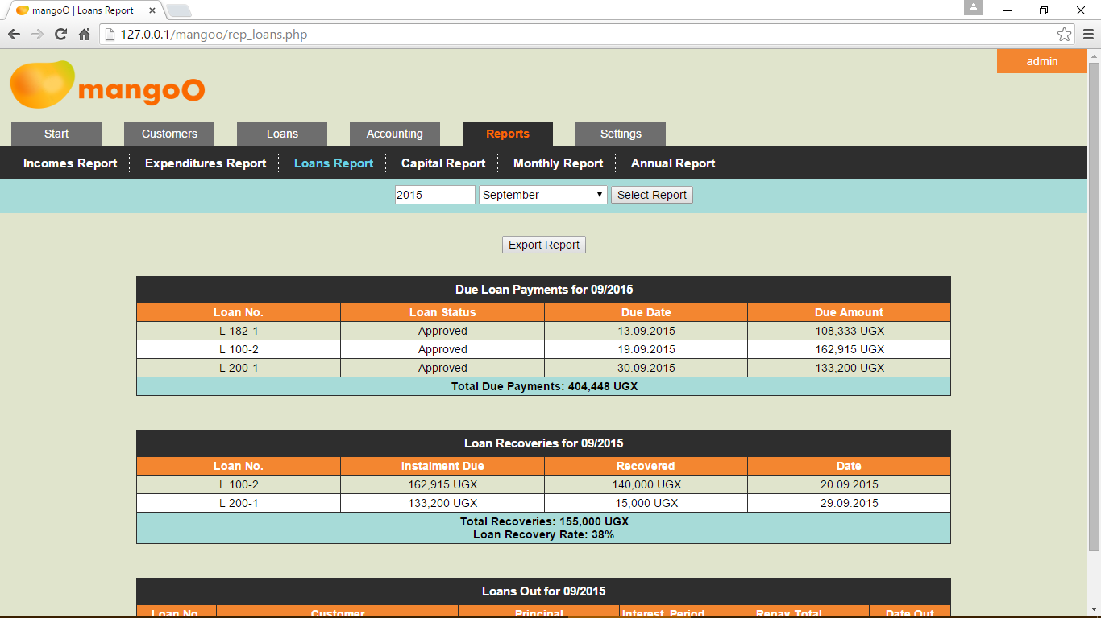
By default, mangoO offers to generate reports for the previous month of the current year.
Clicking Export above the list will generate an XLS file which can then be altered, printed, sent, or otherwise used outside mangoO.
Further types of reports can be programmed by your system administrator or supplier.

Settings
Please note that access to the system settings page is limited to users with the respective permission.

Basic Settings
The Basic Settings page shows several options concerning to system in general.

System-wide settings
Using Dashboard Left and Dashboard Right, the two halves of the user dashboard on the start page (see 1.1) can be configured.
In case the auto-deactivation of unsubscribed customer accounts is activated (see 8.1.4), the left side of the dashboard will automatically be set to Overdue Subscriptions.
In case auto-fining for defaulted loan instalments is activated (see 8.2.5), the right side of the dashboard will automatically be set to Defaulted Loan Instalments.
The system-wide Currency Abbreviation will be used in tables and input fields across mangoO.

Number Settings
Under Customer Number Format a pattern for new customer number must be defined. The following variables are predefined in mangoO:
N - Incremental number
D - Day of membership begin
M - Month of membership begin
Y - Year of membership begin
All variables must be preceded by a leading percentage symbol (%).
Apart from the variables, you may also include any other character string. Any string that is preceded by a leading percentage symbol will show in the new customer number. For example, with the Customer Number Format setting:
%Y%-%Cust_%N
mangoO will produce the following customer number for the 101st customer:
2016-Cust_101
Employee Number Format works accordingly for employee numbers. The same variables apply.

Savings Related Settings
Setting a Minimum Savings Balance will prevent withdrawals that would reduce a customer's savings account to a balance below the specified amount. Setting this option to zero would allow customers to entirely empty their savings account.
Fixed-term Savings Deposits can be toggled on and off using the buttons. When activated, you can define a fixed term for any savings deposit (see 3.2.2).

Auto-Deactivation of Unrenewed Customer Accounts
If the auto-deactivation option for customer accounts is enabled, all customers who have delayed the renewal of their annual subscription will automatically be set to inactive after the specified grace period (in months). Leaving this field empty will disable auto-deactivation.
Please note that as long as this feature is enabled, the left side of the dashboard will automatically be set to Overdue Subscriptions (see 8.1.1).

Loan Settings
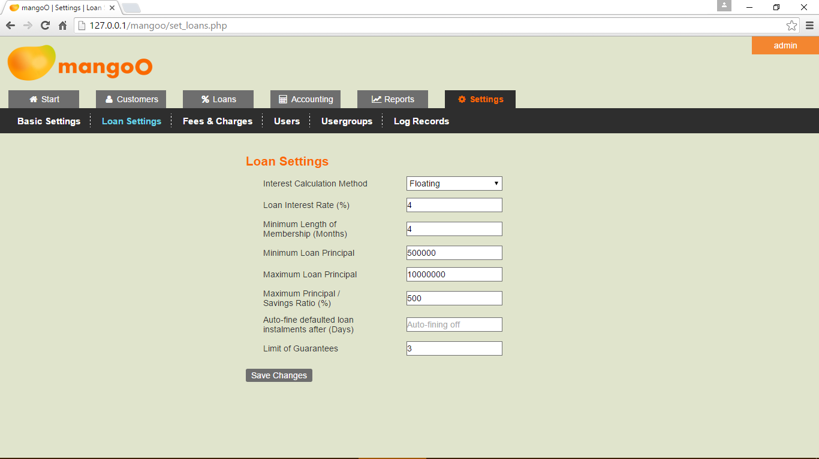

Interest Calculation Method
mangoO supports two different methods of loan interest calculation.
The fixed method calculates the payable interest per month based on the loan's initial principal amount. This results in a fixed interest amount per month.
The floating method calculates the payable interest per month based on the remaining principal balance for the respective loan. This results in a reducing interest amount per month. On each loan payment, the remaining principal and interest is recalculated and updated.

Loan Interest Rate
The Loan Interest Rate is the percentage charged by default as interest on customer loans. Please note that this default rate can be individually adjusted for every loan application (see 4.4).

Minimum Length of Membership
The Minimum Length of Membership option specifies the required duration of membership before a customer is eligible to apply for a loan. Leaving the field empty will deactivate this feature.

Limits on Loan Principal Amount
The values entered in Minimum Loan Principal, Maximum Loan Principal, and Maximum Principal / Savings Ratio set the limits for any loan application.
Minimum Loan Principal and Maximum Loan Principal are fixed amounts, while Maximum Principal / Savings Ratio must be specified as a percentage. For example, a value of 500% will allow any customer to apply for five times the amount of his current savings balance.
In case both Maximum Loan Principal and Maximum Principal / Savings Ratio are set, mangoO will use the smaller of the two amounts to limit the loan principal for any customer.
Leaving any of the fields empty will deactivate the corresponding feature.

Auto-Fining Loan Defaulters
If the auto-fine option for defaulters is selected (see 1.1), loan default fines will automatically be charged and deducted from the defaulter's savings account after a delay that exceeds the specified grace period (in days). Please note, however, that using this option will allow savings accounts to drop to a balance below zero.
Leaving the field empty will deactivate this feature.
Please also note that as long as this feature is enabled, the right side of the dashboard will automatically be set to Defaulted Loan Instalments (see 8.1.1).

Limit of Guarantees
Use this option to limit the number of active loans any customer can guarantee for at a time. Leaving the field empty will deactivate this feature.

Additional Field for Loans
Here you may specify the name of an extra input field for loans. Use this if you require to record additional information related to loans. Leaving this option empty will deactivate the additional input field for loans.

Fees & Charges
This section allows to adjust all fees and charges charged by your institution. All these fees are charged automatically by mangoO as they apply.

Share Value
The current Value of Shares will be used when customers purchase additional shares. mangoO maintains records of all changes in share values.

Membership related Fees
Entrance Fee and Stationary Sales are charged when new members join the financial institution.
Annual Subscription Fee is charged every 12 months to renew a customer's membership. As this fee is not charged automatically, manual renewal of membership is required for every customer (see 2.4.2). Setting this fee to zero will deactivate all features related to annual subscription.

Operational Fees
Withdrawal Fee is charged when customers withdraw money from their savings accounts.

Loan related Fees
Loan Application Fee, is charged when a customer applies for a new loan.
Loan Fee (%) is charged when a loan is set to 'Approved' for the first time.
Loan Insurance (%) is charged when a loan is set to 'Approved' for the first time. Set this fee to '0' if your institution does not charge insurance.
Loan Default Fine specifies the amount that will automatically be charged by mangoO if the Auto-fining option has been enabled (see 8.2.5).
Additional Fee on Loans allows for charging another customised loan related fee. Use this you a require to charge another fee related to loans. Enter the fee's name into the first and the fee's value into the second input field. The fee will be charged on loan disbursement.

Users
On this page, existing users can be edited as well as new ones added to mangoO.

New User Record
In order to create a new mangoO user, fill the fields on the left-hand side of the page. Remember that each user must be assigned to a user group (see 8.5).

Edit Existing User
In order to edit an existing user, click the Edit-symbol next to the user's record in the right-hand section of the page. Whenever you edit an existing user, make sure to also re-type the password, even when it did not change.
Please note that the primary user cannot be assigned to a user group other than Administrator, since mangoO requires at least one user with administrator rights.

Passwords
Passwords need to be at least six characters long.

Linking an Employee to a User Account
If the user is also registered as an employee of your institution (see 5), you may link the employee record to the user by selecting a name from the employees' list. Every employee can be linked to exactly one user account. (Also see 5.1.2)

Usergroups
The permissions management of mangoO is based on user groups. On this page, existing usergroups can be edited as well as new ones added to mangoO.

New Usergroup
In order to create a new usergroup, fill the fields on the left-hand side of the page. Choose the appropriate permissions for each group by using the checkboxes.

Edit Existing Usergroup
In order to edit an existing usergroup, click the Edit-symbol next to the usergroup's record in the right-hand section of the page. Remember that when changing permissions for a usergroup, all users in this group will be hold these new permissions.

Deleting Usergroups
To delete a usergroup, click the Delete-symbol next to the usergroup's record. Please note that a usergroup cannot be deleted while it still has members.

Administrator Usergroup
Please note that the primary usergroup Administrator can neither be changed nor deleted.

Log Records
The list under Log Records allows to monitor login and log off activities of all mangoO users. In case a user forgot to log out from the system and his session was forcibly ended, the log-off time will show in red. Such a user will see a logout reminder message the next time he or she logs in to mangoO.

